SQL Assignment 1

create table salespeople (
-> Snum int(4),
-> Sname varchar(10),
-> City varchar(10),
-> Comm float(3,2)
-> );
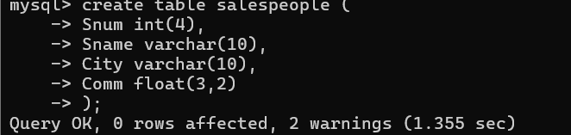
create table orders(
-> Onum int(4),
-> Amt float(7,2),
-> Odate date,
-> Cnum int(4),
-> Snum int(4)
-> );
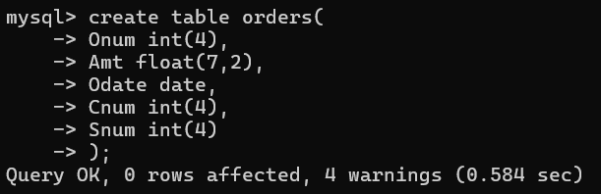

mysql> create table customers (
-> Cnum int(4),
-> Cname varchar(10),
-> City varchar(10),
-> Rating int(4),
-> Snum int(4)
-> );
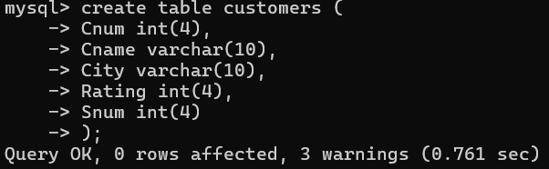

Insert into salespeople (Snum,Sname,City,Comm)
Values(1001,'Peel','London',0.12),
(1002,'Serres','San Jose',0.13),
(1004,'Motika','London',0.11),
(1007,'Rifkin','Barcelona',0.15),
(1003,'Axelrod','New York',0.10);
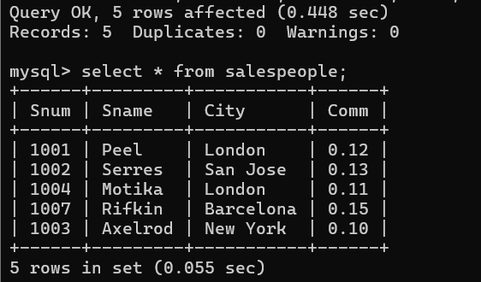

Insert into customers (Cnum,Cname,City,Rating,Snum)
Values(2001,'Hoffman','London',100,1001),
(2002,'Giovanni','Rome',200,1003),
(2003,'Liu','San Jose',200,1002),
(2004,'Grass','Berlin',300,1002),
(2006,'Clemens','London',100,1001),
(2008,'Cisneros','San jose',300,1007),
(2007,'Pereira','Rome',100,1004);
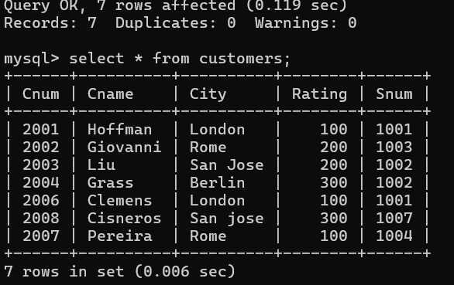

Insert into Orders (Onum,Amt,Odate,Cnum,Snum)
Values(3001,18.69,'1990-10-03',2008,1007),
(3003,767.19,'1990-10-03',2001,1001),
(3002,1900.10,'1990-10-03',2007,1004),
(3005,5160.45,'1990-10-03',2003,1002),
(3006,1098.16,'1990-10-03',2008,1007),
(3009,1713.23,'1990-10-04',2002,1003),
(3007,75.75,'1990-10-04',2004,1002),
(3008,4723.00,'1990-10-05',2006,1001),
(3010,1309.95,'1990-10-06',2004,1002),
(3011,9891.88,'1990-10-06',2006,1001);
